* 1. **Constrained engineering design problems**
     1. *Problem 1: Tension/compression spring design*

The main objective of this problem is to minimize the weight of spring. There are three variables in the definition of problem. These are the wire diameter (d), mean coil diameter (D), and the number of active coils (P). In the optimization process, the problem constraints surge frequency, minimum deflection, and shear stress are considered. Figure 1 shows the schematic illustration of the problem.

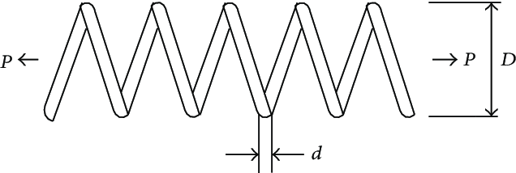

**Fig. 1.** Tension/compression spring design problem

The ranges of variables are given in Table 1. The mathematical formulation of objective function and constraints of this problem are described as follows:

|  |  |
| --- | --- |
|  | (1) |

* + 1. *Problem 2: Pressure vessel design*

The pressure vessel problem is a structural engineering optimization problem including the cost of the materials, forming and welding. Please see the Fig.2. for schematic illustration of it and its features. There are four design variables: thickness of pressure vessel (*Ts*), thickness of head (*Th*), inner radius of the vessel (*R*) and length of the vessel (*L*) without the heads. The ranges of design variables are given in Table 1. The mathematical formulation of objective function and constraints of this problem are described as follows:

|  |  |
| --- | --- |
| $$Consider \vec{x}=\left[x_{1}x_{2}x_{3}x_{4}\right]=\left[T_{s}T_{h}RL\right], \\ Minimize f\left(\vec{x}\right)=0.6224x_{1}x_{3}x_{4}+1.7781x_{2}x_{3}^{2}+3.1661x_{1}^{2}x_{4}+19.84x_{1}^{2}x_{3}, \\ Subject to: \\ g_{1}\left(\vec{x}\right)=0.0193x_{3}-x_{1}≤0, g_{2}\left(\vec{x}\right)=0.00954x_{3}-x_{2}≤0, \\ g_{3}\left(\vec{x}\right)=1296000-πx_{3}^{2}x_{4}-\frac{4}{3}πx_{3}^{3}≤0, g_{4}\left(\vec{x}\right)=x_{4}-240≤0, \\ where: 1*0.0625≤x_{1},x_{2}≤99*0.0625, 10.0≤x_{3}x_{4}≤200.0$$ | (2) |

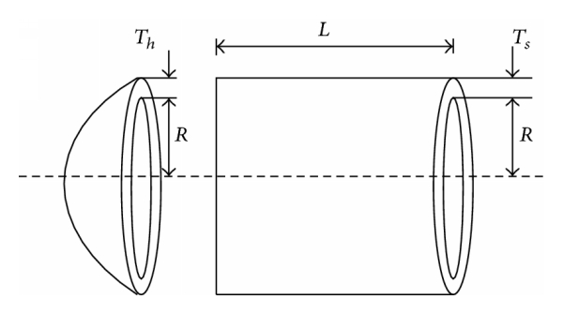

Fig.2. Pressure vessel design problem [58]

* + 1. *Problem 3: Welded beam design*

The welded beam problem is a structural engineering optimization problem. The objective of this problem is to find the best dimensions for design variables *b*, *t*, *h* and *l* which are used to move a P load and support the minimum production cost. Please see the Fig.3. for schematic illustration of it and its features. There are four design variables: the thickness of weld (*h*), the length of attached part of the bar (*l*), the height of the bar (*t*), and thickness of the bar (*b*). The ranges of design variables are given in Table 1.

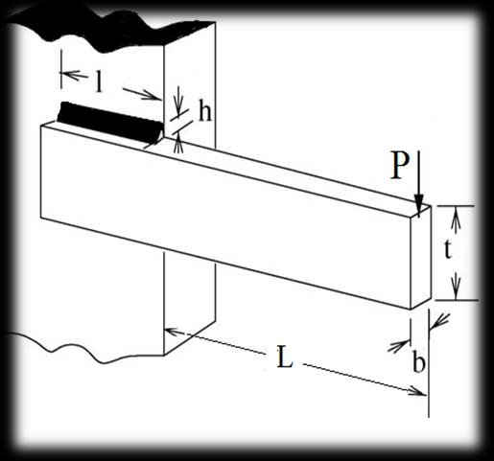

Fig. 3. Welded beam design problem [59]

The mathematical formulation of objective function and constraints of this problem are described as follows:

|  |  |
| --- | --- |
|  | (3) |

* + 1. *Problem 4: Speed reducer design*

The speed reducer design is a minimization problem. The objective of this problem is to find the minimum weight of speed reducer. It has seven design variables. These are the face width (x1), module of teeth (x2), number of teeth in the pinion (x3), length of the first shaft between bearings (x4), length of the second shaft between bearings (x5), and the diameters of the two shafts (x6, x7). Please see the Fig.4. for schematic illustration of it and its features.

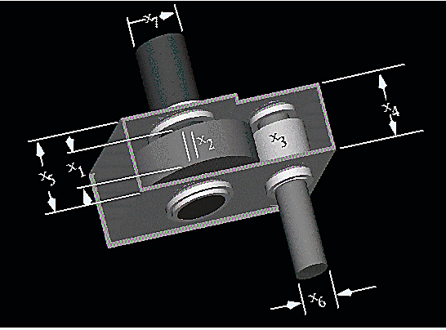

Fig. 4. Speed reducer design problem [60]

The mathematical formulation of objective function and constraints of this problem are described as follows:

|  |  |
| --- | --- |
|  | (4) |

* + 1. *Problem 5: Gear train design*

The objective of this design problem is to explore the optimal number of tooth for four gears ($T_{a}T_{b}T_{d}T_{f}$) of a train to minimize the gear ratio. The mathematical formulation of objective function and constraints of this problem are described as follows:

|  |  |
| --- | --- |
| $$Consider \vec{x}=\left[x_{1}x_{2}x_{3}x_{4}\right]=\left[T_{a}T_{b}T_{d}T_{f}\right], \\ Minimize f\left(\vec{x}\right)={\left(\frac{1}{6.931}-\frac{x_{2}x_{3}}{x_{1}x_{4}}\right)}^{2}, where:12≤x_{1},x_{2},x_{3},x_{4}≤60$$ | (5) |

For detailed information about design problems, please follow the reference studies [1-13].

1. Arora, S., & Singh, S. (2019). Butterfly optimization algorithm: a novel approach for global optimization. Soft Computing, 23(3), 715-734.
2. Çivicioğlu Beşdok P., Beşdok E., Günen M.A., Atasever Ü.H., (2018) Weighted differential evolution algorithm for numerical function optimization: A comparative study with cuckoo search, artificial bee colony, adaptive differential evolution, and backtracking search optimization algorithms, Neural Computing & Applications,1-15.
3. Singh, P. R., Elaziz, M. A., & Xiong, S. (2018). Modified Spider Monkey Optimization based on Nelder–Mead method for global optimization. Expert Systems with Applications, 110, 264-289.
4. Mortazavi, A., Toğan, V., & Nuhoğlu, A. (2018). Interactive search algorithm: a new hybrid metaheuristic optimization algorithm. Engineering Applications of Artificial Intelligence, 71, 275-292.
5. Wu, L., Liu, Q., Tian, X., Zhang, J., & Xiao, W. (2018). A new improved fruit fly optimization algorithm IAFOA and its application to solve engineering optimization problems. Knowledge-Based Systems, 144, 153-173.
6. Aydilek, İ. B. (2018). A hybrid firefly and particle swarm optimization algorithm for computationally expensive numerical problems. Applied Soft Computing, 66, 232-249.
7. Sadollah, A., Sayyaadi, H., Yoo, D. G., Lee, H. M., & Kim, J. H. (2018). Mine blast harmony search: A new hybrid optimization method for improving exploration and exploitation capabilities. Applied Soft Computing, 68, 548-564.
8. Moghdani, R., & Salimifard, K. (2018). Volleyball Premier League Algorithm. Applied Soft Computing, 64, 161-185.
9. Awad, N. H., Ali, M. Z., Mallipeddi, R.,Suganthan, P. N. (2018). An improved differential evolution algorithm using efficient adapted surrogate model for numerical optimization. Information Sciences, 451, 326-347.
10. Long, W., Wu, T., Liang, X., & Xu, S. (2019). Solving high-dimensional global optimization problems using an improved sine cosine algorithm. Expert Systems with Applications, 123, 108-126.
11. Dong, M., Wang, N., Cheng, X., & Jiang, C. (2014). Composite differential evolution with modified oracle penalty method for constrained optimization problems. Mathematical Problems in Engineering, http://dx.doi.org/10.1155/2014/617905, 1-15.
12. Amir Mosavi, Towards An Approach For Effectively Using Intuition In Large-Scale Decision-Making Problems, PhD Thesis, University of Debrecen, 2013.
13. Lin, X., Zhang, F., & Xu, L. (2017, November). Design of Gear Reducer Based on FOA Optimization Algorithm. In International Conference on Smart Vehicular Technology, Transportation, Communication and Applications (pp. 240-247). Springer, Cham.